Email Notifications

What it does:
Specific events in LiveText can be set to trigger an email be sent to one or both of the user’s email addresses. The frequency of automated messages from LiveText can also be set. The selected event(s) can be set to trigger notifications immediately, or to send summary emails of what events occurred in the last day, week or month. This feature is available to students as well, with events specific to their role. So if your students have asked for notifications when assignments are posted or assessed – or if you have found it necessary to remind students to check LiveText – you may want to recommend that students begin using this feature to receive their alerts automatically.

How it works:
Email notifications are DISABLED by default. You will need to enable notifications in your account by choosing which notifications you want to receive and how often you want to receive them. To enable email notifications in your account:
- Log in and click on the My Account link in the upper right corner.
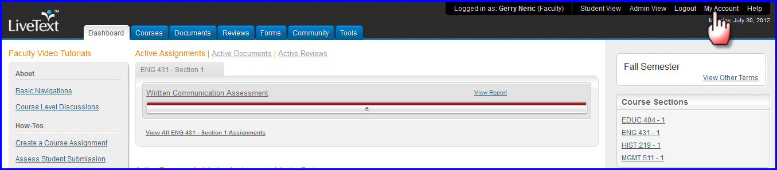
- Scroll to the bottom of the page to find the Notifications section, click Edit to the right.

- Select which email address(es) the notifications should be sent to.
- Select which notifications which will be sent.
- Choose the frequency with which notifications will be sent.
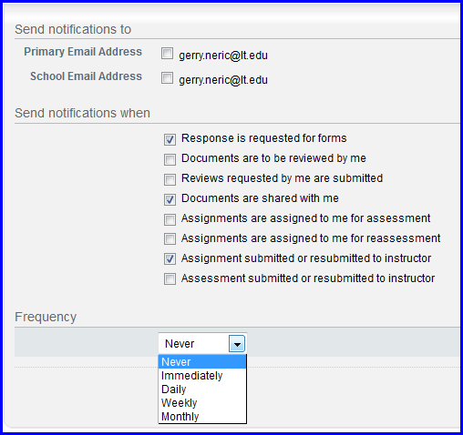
- Click save.
To ensure delivery of all notifications, make sure that notifications@livetext.com is one of your safe senders or is one of your allowed contacts. Initially, users should check spam or junk mail filters to make sure that notifications are not inadvertently filtered.
The notifications available are:
Response is requested for forms – A new form has been launched to me to fill out.
Documents are to be reviewed by me – Another other user has used the “send for review” function to request that I provide review, commentary, and scoring of their document.
Reviews requested by me are submitted – A review that I requested of another user has been completed and I can view the results.
Documents are shared with me – Another person has given me permission to view or edit their document in the Documents Inbox.
Assignments are assigned to me for assessment – Another faculty member has invited me to be an assessor on a new assignment.
Assignments are assigned to me for reassessment – The instructor of record of a course where I am an additional assessor has asked me to re-do an assessment.
Assignment submitted or resubmitted to instructor – A student has made a submission or resubmission to one of my course assignments.
Assessment submitted or resubmitted to instructor – A third party assessor invited to assess one of my course assignments has submitted their assessments and/or comments.

