Email Notifications

What it does:
Specific events in LiveText can be set to trigger an email be sent to one or both of the user’s email addresses. The frequency of automated messages from LiveText can also be set. The selected event(s) can trigger notifications immediately, or be set to send summary emails of what events occurred in the last day, week or month.

How it works:
Email notifications are DISABLED by default. You will need to enable notifications in your account by choosing which notifications you want to receive and how often you want to receive them. To enable email notifications in your account:
- Log in and click on the My Account link in the upper right corner.
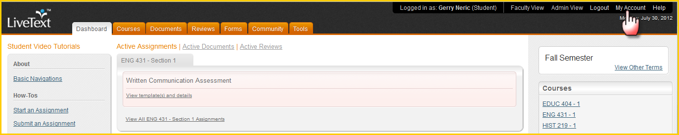
- Scroll to the bottom of the page to find the Notifications section, click Edit to the right.
- Select which email address(es) the notifications should be sent to.
- Select which notification(s) you wish to receive.
- Choose the frequency with which notifications will be sent.
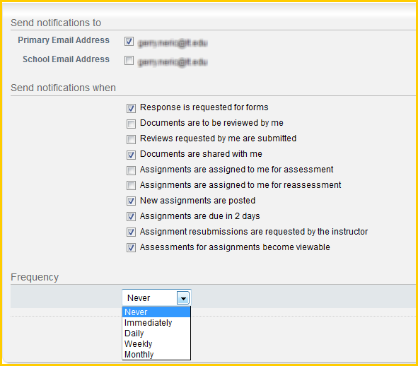
- Click save.
To ensure delivery of all notifications, make sure that notifications@livetext.com is one of your safe senders or is one of your allowed contacts. Initially, users should check spam or junk mail filters to make sure that notifications are not inadvertently filtered.
The notifications available are:
Response is requested for forms – A new form has been launched to me to fill out.
Documents are to be reviewed by me – Another other user has used the “send for review” function to request that I provide review, commentary, and scoring of their document.
Reviews requested by me are submitted – A review that I requested of another user has been completed and I can view the results.
Documents are shared with me – Another person has given me permission to view or edit their document in the Documents Inbox.
Assignments are assigned to me for assessment – A faculty member has invited me to be an assessor on a new assignment.
Assignments are assigned to me for reassessment – The instructor of record of a course where I am an additional assessor has asked me to re-do an assessment.
New assignments are posted – A new assignment has been created in a course that I am enrolled in.
Assignments are due in 2 days – An assignment in this one of my course is nearing its due date. Note: If notification frequency is set to Weekly or Monthly, you may not receive a notification before the due date has passed.
Assignment resubmissions are requested by the instructor – The instructor of one of my courses has submitted comments, draft assessments or notes back and has requested that I re-submit the assignment.
Assessments for assignments become viewable – The instructor has posted final comments, grades or an assessment of an assignment for me to view.

